Install GIT & make sure it is added into PATH.

Section 0 -Use GIT as local VCS. Steps to follow:

1. Create a directory ‘project_dir’ & cd to ‘project_dir’.

**mkdir project_dir**

**cd project_dir**

1. Initialize git version database. (git init)

**git init**

1. Create a new file index.html.

**touch index.html**

1. Check the git status. You should find index.html as untracked file.

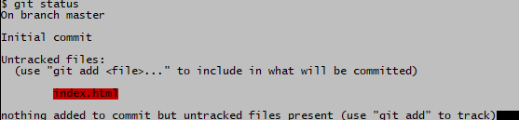

1. Stage the index.html file.

**git add index.html**

1. Commit index.html

**git commit -m ‘added the index.html’**

1. Make few changes in index.html & create a new file info.txt file.

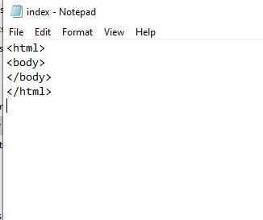

**touch info.txt**

1. Check git status. You should find index.html & info.txt as untracked files.

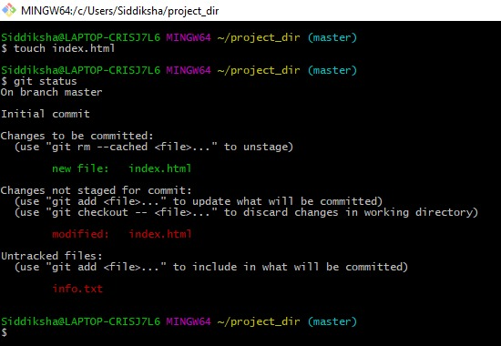

1. Configure GIT to ignore all txt files.

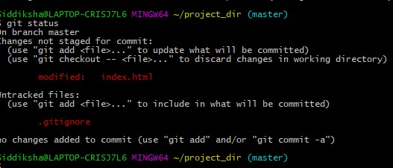

1. Again check the git status. You should find only index.html as untracked file.



1. State & commit index.html

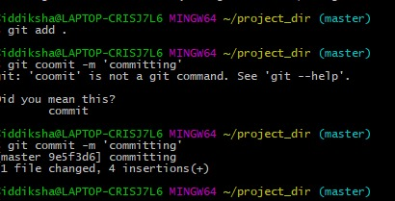

1. Log all your comments so far.

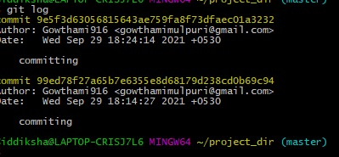

1. Make some changes in index.html.

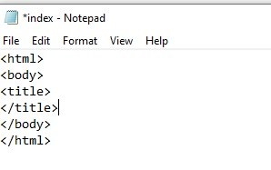

1. Revert the change made in the previous step using git command.

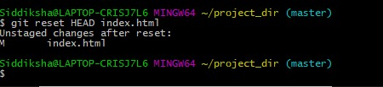

1. Again change index.html.

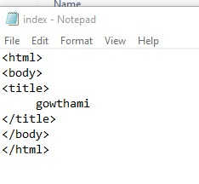

1. Stage index.html

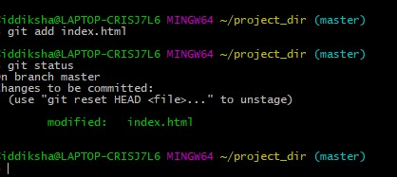

1. Revert back the last stage.

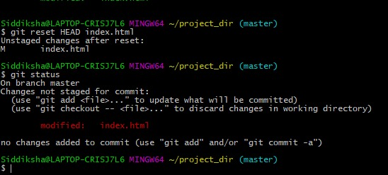

1. Rename ‘add’ command to ‘my-add’.

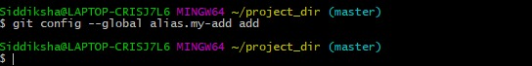

1. Using my_add command Stage index.html again & commit the changes.

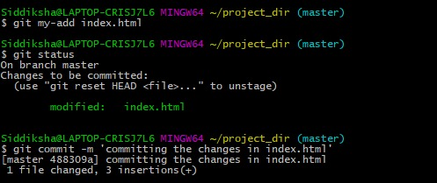

1. Revert the last commit.

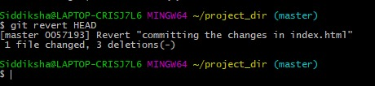

*GIT Branching*

Objective: Commit HTML, CSS & JavaScript assignments into GIT.

SECTION-1 (HTML assignments) - Steps to follow:

1. First take a backup of your assignments & projects. This is required because due to incorrect GIT operation you may lose your files.

**git config --global user.username Gowthami916**

**git config --global https://github.com/Gowthami916.repo.git**

1. Create an empty directory ‘Assignments’ & cd to ‘Assignments’.

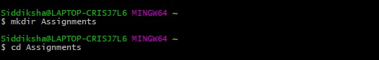

1. Create a file README.txt inside ‘Assignments’ & write few lines about the contents of ‘Assignments’ folder.

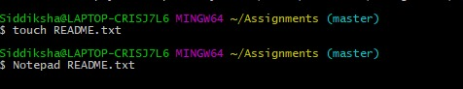

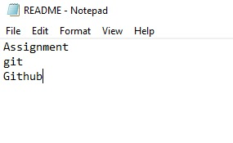

1. Commit README.txt file.

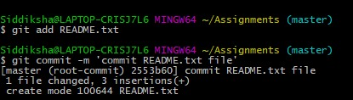

1. Now create a new branch ‘html-assignments’.

WhatsApp Image 2021-09-29 at 8.25.54 PM (5)

1. Switch to ‘html-assignments’ branch.

WhatsApp Image 2021-09-29 at 8.25.54 PM (6)

1. Copy all HTML assignments inside ‘Assignments’ folder.

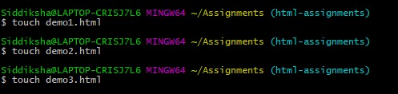

1. Commit HTML assignments into ‘html-assignments’ branch.

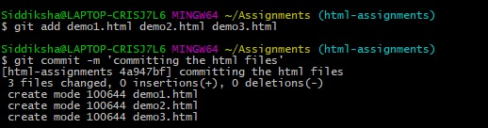

1. Make minor changes into few files belonging to ‘html-assignments’ branch.

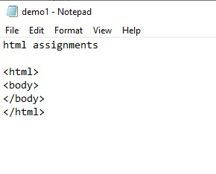

1. Commit those changed files.

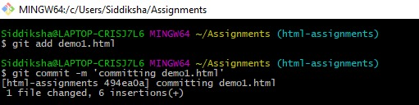

1. Switch to master branch.

WhatsApp Image 2021-09-29 at 9.32.00 PM (1)

1. Make minor changes into README.txt file & commit those changes into master.

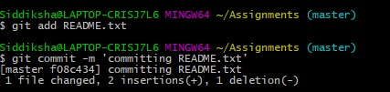

1. Again switch to ‘html-assignments’ branch.

WhatsApp Image 2021-09-29 at 9.32.00 PM (3)

1. Make minor changes into few files belonging to ‘html-assignments’ branch.

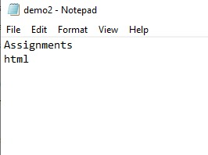

1. Commit those changes.

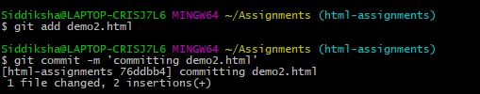

1. Switch to master.

WhatsApp Image 2021-09-29 at 9.32.00 PM (1)

1. Merge ‘html-assignments’ branch into master. Confirm all html assignments are shown in master.

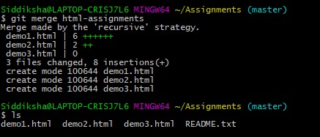

1. Finally delete the ‘html-assignments’ branch.

WhatsApp Image 2021-09-29 at 9.29.19 PM

SECTION-2 - (CSS assignments) Steps to follow:

1. Create a new branch ‘css-assignments’.

WhatsApp Image 2021-09-29 at 10.24.38 PM (3)

1. Switch to ‘css-assignments’ branch.

WhatsApp Image 2021-09-29 at 10.24.38 PM (4)

1. Copy all CSS assignments inside ‘Assignments’ folder.

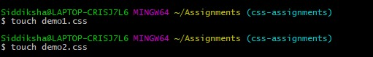

1. Commit CSS assignments into ‘css-assignments’ branch.

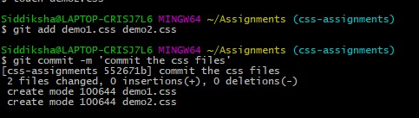

1. Make minor changes into README.txt file on line 1 belonging to ‘css-assignments’ branch.

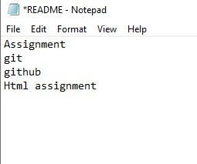

1. Commit those changed files.

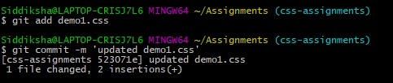

1. Switch to master branch.

WhatsApp Image 2021-09-29 at 10.03.08 PM (1)

1. Make minor changes into README.txt file on line 3 & commit those changes into master.

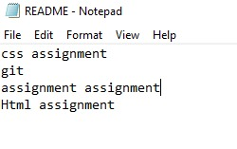



1. Again switch to ‘css-assignments’ branch.

WhatsApp Image 2021-09-29 at 10.03.08 PM (5)

1. Make minor changes into few files belonging to ‘css-assignments’ branch.

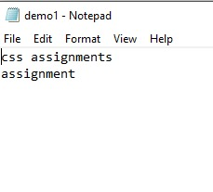

1. Commit those changes.



1. Switch to master.
2. WhatsApp Image 2021-09-29 at 10.03.08 PM (1)
3. Merge ‘css-assignments’ branch into master. Confirm all css assignments are shown in master.

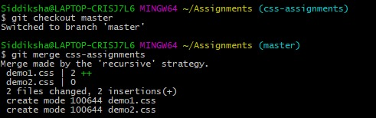

1. Finally delete the ‘css-assignments’ branch.

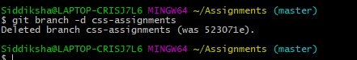

SECTION-3 - (JavaScript assignments) Steps to follow:

1. Create a new branch ‘js-assignments’.

WhatsApp Image 2021-09-29 at 10.24.38 PM

1. Switch to ‘js-assignments’ branch.

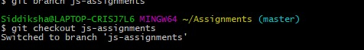

1. Copy all JavaScript assignments inside ‘Assignments’ folder.

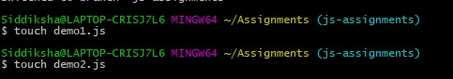

1. Commit JavaScript assignments into ‘js-assignments’ branch.

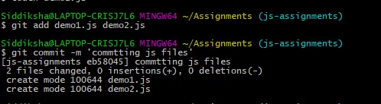

1. Make minor changes into README.txt file on line 1 belonging to ‘js-assignments’ branch.

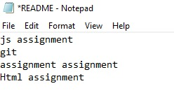

1. Commit those changed files.

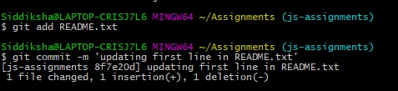

1. Switch to master branch.

WhatsApp Image 2021-09-29 at 10.24.38 PM (9)

1. Make minor changes into README.txt file on line 1 & commit those changes into master.

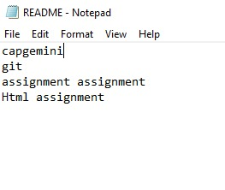



1. Again switch to ‘js-assignments’ branch.



1. Make minor changes into few files belonging to ‘js-assignments’ branch.

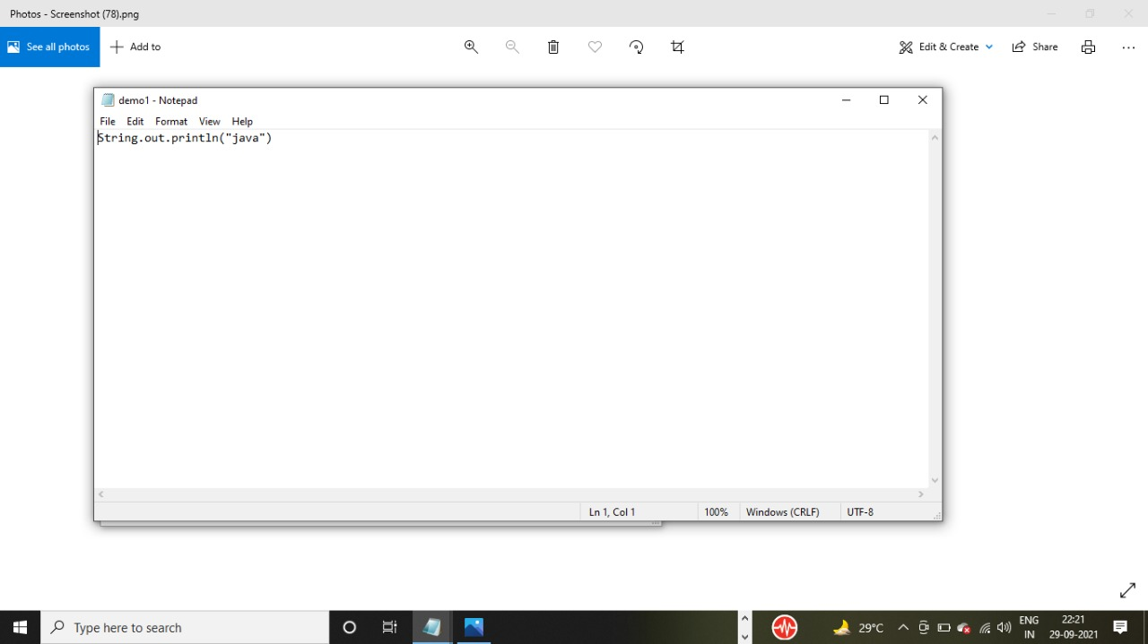

1. Commit those changes.

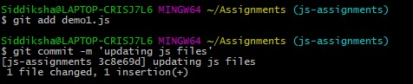

1. Switch to master.

WhatsApp Image 2021-09-29 at 10.24.38 PM (9)

1. Merge ‘js-assignments’ branch into master. Confirm all JavaScript assignments are shown in master.

**git merge js-assgnments**

1. Finally delete the ‘js-assignments’ branch.

**git branch -d js-assignments**

*GIT Remoting*

Objective: Pushing source code into GITHUB & collaborate team members.

SECTION-3 (Pushing assignments to remote repository) - Steps to follow:

1. Create a github account if you do not have already.
2. Login on into github account.
3. Create new public repository ‘freshersbatch-oct16’.
4. Commit & push any sample file to this repository under ‘Assignments’ directory.

**git add README.txt**

**git commit -m ‘committing README.txt’**

SECTION-4 (Pushing source code to remote repository using Eclipse GIT plugin) - Steps to follow:

1. One developer from project team will create eclipse projects ‘SampleProj’ & add sample source code files. Then commit all files through eclipse GIT plugin.
2. Collaborate other team members with your github account so that they can also modify the committed files.
3. Other developers from same team will checkout all files from remote repository. This might get conflicts since certain files fail to merge. In such case, merge it manually.
4. Commit & push the ‘SampleProj’ project.